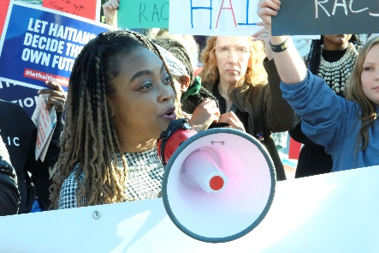 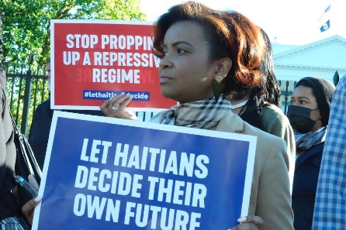 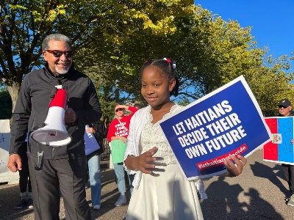

**National Day of Action to Support the Haitian People**

**Thursday, September 21, 2023**Washington, DC and across the U.S.

Please join Haitian-Americans, religious leaders, and friends of Haiti in Washington, DC and across the U.S. in calling on Congress to stand with the Haitian People.

We must speak out forcefully to send a loud message to our U.S. Representatives and Senators to support:

* Restoring democracy in Haiti by ending U.S. support for the corrupt and anti-democratic regime ruling Haiti and supporting a Haitian-led transition
* Restoring security in Haiti by stopping the flow of weapons and sanctioning collusion between gangs and Haitian elites
* Fighting rising hunger in Haiti by supporting local Haitian farmers
* Ending abuse and discrimination against Haitian and other Black migrants and delays in work permits to people with TPS and Humanitarian Parole

**How you can participate**

* Come to Washington, DC for a big Advocacy Day on Capitol Hill – help reach our goal of 100 in-person meetings with Members of Congress.
* Set up virtual meetings with your Members of Congress and their staff.
* Stay on to participate in the Congressional Black Caucus Legislative Conference

**Sign-up to co-sponsor and participate in the Day of Action**

**For organizations**: [Sign up as a co-sponsor](https://docs.google.com/forms/d/1pcUB8bU3q6W2m42Iwc06uDvNueuoaGPpR1aAC49IBlk/edit). This is a shared event led by all of the co-sponsoring organizations.

**For individuals**: [Sign up to participate](https://docs.google.com/forms/d/1zu3XVdMkNGmdTqM9ZtWBHmw8bxXq6jUxyKieQHhdExs/edit) in Washington, DC or in your community.